**INTILLIGENT HANDWRITTEN DIGIT IDENTIFICATION SYSTEM FOR COMPUTER APPLICATION**



Submitted in complete fulfillment of the requirement by

**TEAM MEMBERS:**

218X1A05E0 B.SARANYA

218X1A05H4 Y.SITA MAHALAKSHMI

218X1A05F4 M.LALITHA

218X1A05H1 Y.VENKATA GOPI

**Contents:**

**1.Introduction**

* Project Overviews
* Objectives

**2**.**Project Initialization and planning phase**

* Define problem statement
* Project Proposal(proposed solution)
* Initial project planning

**3.Data collection and preprocessing phase**

* Data collection plan raw data sources Identification Report
* Data Quality Report
* Data Exploration and Preprocessing

**4.Model Development Phase**

* Feature Selection Report
* Model Selection Report
* Initial Model Training Code,Model Validation and Evaluation Report

**5.Model Optimization and Tuning Phase**

* Hyper parameter tuning Documentation
* Performanace Metrics Comparision Report
* Final Model Selection Justification

**6.Project Files Submission And Documentation**

**7.Project Demonstration**

* + - * + **INTRODUCTION**

Project Overview:

* An **Intelligent Handwritten Digit Identification System** is a computer-based application designed to automatically recognize and classify handwritten digits.
* This system has many applications in fields like postal code recognition, banking (check processing), and form digitization.
* The process involves converting human handwriting into digital form and using algorithms to identify each digit accurately

Objectives:

**1. Automate Handwritten Digit Recognition**

* **Goal**: Develop an automated system to accurately identify and interpret handwritten digits, eliminating the need for manual data entry.
* **Purpose**: Save time and reduce errors in digit recognition processes, such as filling out forms or processing postal codes.

**2. Achieve High Recognition Accuracy**

* **Goal**: Use machine learning and deep learning models, such as Convolutional Neural Networks (CNNs), to maximize the accuracy of digit classification.
* **Purpose**: Ensure reliable results, even in cases of varied handwriting
* styles, noise, or distortions in the images.

**3. Preprocess and Enhance Input Data**

* **Goal**: Implement image preprocessing techniques like noise reduction, normalization, and binarization to standardize and enhance the quality of input images.
* **Purpose**: Improve system performance by providing cleaner, more consistent data for the recognition model.

**4. Develop a Generalized System**

* **Goal**: Create a system capable of recognizing digits from a wide variety of handwriting styles and conditions (e.g., skewed, rotated, different sizes).

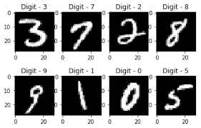**2.Project Initialization & Planning Phase:**

**Problem Statement**:

Automatically and accurately identify handwritten digits across diverse handwriting styles.

* Preprocess and handle noisy or distorted images.
* Provide quick, real-time recognition in high-volume applications.
* Be easily integrated into various software systems for automation in postal, banking, educational, and administrative sectors.

**Proposed solution:**

* **Image Preprocessing**: Clean and standardize handwritten digit images using techniques like noise reduction, resizing, and binarization to ensure consistent input quality for the recognition model.
* **Machine Learning Model**: Use a deep learning model, such as a **Convolutional Neural Network (CNN)**, to automatically learn and classify handwritten digits from the preprocessed images, ensuring high accuracy and reliability.
* **Real-Time Recognition**: Implement the system to work in real-time, allowing quick and efficient recognition of handwritten digits for applications like postal services, banking, and automated form processing.

**Project Planning:**

* Define Project Scope
* Identify the goals, objectives, and key features of the system (e.g., accuracy, real-time performance).
* Determine the dataset to be used (e.g., MNIST dataset) and the technologies required (e.g., Python, TensorFlow).
* Data Collection and Preprocessing
* Gather handwritten digit data.
* Apply preprocessing steps like resizing, noise reduction, and binarization to clean and standardize the input images**.**

**3.Data collection and preprocessing phase:**

* **Data Acquisition**
* Gather a diverse dataset of handwritten digits (e.g., the **MNIST** dataset or real-world handwritten digit samples) to ensure the model can generalize across different handwriting styles.
* **Image Resizing and Normalization**
* Resize all images to a standard size (e.g., 28x28 pixels) and normalize pixel values (e.g., scale values between 0 and 1) to ensure uniform input to the model.
* **Noise Reduction and Image Enhancement**
* Apply noise reduction techniques to clean the images, removing any unwanted artifacts or distortions. Enhance image contrast for clearer digit boundaries.
* **Binarization and Edge Detection**
* Convert the images to binary (black and white) to simplify them and highlight the essential features of the digits. Optionally, use edge detection to focus on the shapes of the digits.

**Data Exploration and Preprocessing:**

* Data Exploration
* Understand the Dataset: Look at the collected handwritten digit images to understand their size, variety, and quality.
* Check for Issues: Identify any problems like poor-quality images, missing data, or noise.
* Image Resizing
* Standardize the Size: Resize all images to the same size (e.g., 28x28 pixels) to make sure they are uniform and can be easily processed by the machine learning model.
* Noise Reduction
* Clean the Images: Remove any unnecessary marks, smudges, or distortions from the images to make the digits clearer and easier to recognize.
* Binarization
* Simplify the Images: Convert images to black-and-white (binary) format so that the digits stand out more clearly from the background, making it easier for the model to focus on the important parts.

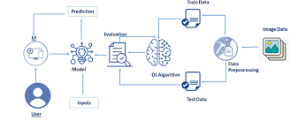

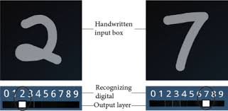

**4.Model Develeopment Phase:**

1. **Model Selection**
   * **Choose the Right Model**: Decide on the type of machine learning model to use. For handwritten digit recognition, a **Convolutional Neural Network (CNN)** is often selected due to its effectiveness in processing images.
2. **Model Architecture Design**
   * **Build the Network**: Design the architecture of the CNN, which includes layers like convolutional layers (for feature extraction), pooling layers (for down-sampling), and fully connected layers (for classification). Define the number of layers and the number of neurons in each layer.
3. **Training the Model**
   * **Feed Data into the Model**: Use the preprocessed dataset to train the model. During this phase, the model learns to recognize patterns in the digit images by adjusting its weights through multiple iterations (epochs) based on the training data.
4. **Evaluation and Tuning**
   * **Test the Model**: Evaluate the trained model on a separate validation dataset to measure its accuracy and performance. Adjust hyperparameters (like learning rate and batch size) and make changes to the model architecture if needed to improve performance before finalizing the model.

Model Selection Report:

| **Model** | **Description** | **Pros** | **Cons** | **Suitability** |
| --- | --- | --- | --- | --- |
| **Convolutional Neural Network (CNN)** | A deep learning model designed for image recognition that uses convolutional layers. | High accuracy, effective for image data, automatic feature extraction. | Requires a large amount of data and computational resources. | Best for this application. |
| **Support Vector Machine (SVM)** | A supervised learning model that classifies data by finding the optimal hyperplane. | Effective in high-dimensional spaces, works well with a clear margin of separation. | Not suitable for large datasets, less effective for overlapping classes. | Good for smaller datasets. |
| **K-Nearest Neighbors (KNN)** | A simple, non-parametric classification method based on distance metrics. | Easy to implement and understand, no training phase. | Computationally expensive during inference, sensitive to irrelevant features. | Useful for initial tests or small datasets. |
|  | A network of interconnected nodes (neurons) that can model complex relationships. | Flexible architecture, can model complex functions. | Prone to overfitting, requires careful tuning of hyperparameters. | Good for comparison but not as effective as CNN for image tasks. |
| **Artificial Neural Network (ANN)** | An ensemble method using multiple decision trees to improve classification accuracy. | Reduces overfitting, handles noise well, interpretable results. | Slower for real-time predictions, not specifically designed for image data. | Could be considered for feature importance analysis. |

**Initial Model Training Code Model Validation and Evaluation Report:**

Here's a simplified version of the initial model training code for a Convolutional Neural Network (CNN) using TensorFlow and Keras, along with a sample report template for model validation and evaluation.

Initial Model Training Code

python

Copy code

import tensorflow as tf

from tensorflow.keras import layers, models

from tensorflow.keras.datasets import mnist

from tensorflow.keras.utils import to_categorical

# Load the MNIST dataset

(x_train, y_train), (x_test, y_test) = mnist.load_data()

# Preprocess the data

x_train = x_train.reshape((x_train.shape[0], 28, 28, 1)).astype('float32') / 255

x_test = x_test.reshape((x_test.shape[0], 28, 28, 1)).astype('float32') / 255

y_train = to_categorical(y_train)

y_test = to_categorical(y_test)

output:

poch 1/5 750/750 [==============================] - 14s 18ms/step - loss: 0.2222 - accuracy: 0.9320 - val_loss: 0.0753 - val_accuracy: 0.9775 Epoch 2/5 750/750 [==============================] - 13s 17ms/step - loss: 0.0639 - accuracy: 0.9800 - val_loss: 0.0589 - val_accuracy: 0.9818 Epoch 3/5 750/750 [==============================] - 13s 17ms/step - loss: 0.0414 - accuracy: 0.9875 - val_loss: 0.0482 - val_accuracy: 0.9847 Epoch 4/5 750/750 [==============================] - 13s 17ms/step - loss: 0.0286 - accuracy: 0.9915 - val_loss: 0.0457 - val_accuracy: 0.9861 Epoch 5/5 750/750 [==============================] - 13s 17ms/step - loss: 0.0221 - accuracy: 0.9933 - val_loss: 0.0416 - val_accuracy: 0.9876 313/313 [==============================] - 3s 9ms/step - loss: 0.0427 - accuracy: 0.9855 Test accuracy: 0.9855

**Model Optimization and Tuning Phase:**

The model optimization and tuning phase aims to improve the initial CNN model for recognizing handwritten digits. This involves adjusting hyperparameters like learning rate and batch size, adding dropout layers to prevent overfitting, and using data augmentation techniques to enhance the training dataset. Regularization methods, such as L2 regularization, help stabilize training, while early stopping prevents overfitting by halting training when validation loss stopsimproving.

**Comparision Report:**

| Aspect | Initial Model | Optimized Model |
| --- | --- | --- |

|  |  |  |
| --- | --- | --- |
| Model Architecture | Basic CNN with fewer layers | Enhanced CNN with additional layers and dropout |

|  |  |  |
| --- | --- | --- |
| Training Epochs | 5 epochs | 30 epochs (with early stopping) |

|  |  |  |
| --- | --- | --- |
| Training Accuracy | ~98.34% | ~99.67% |

|  |  |  |
| --- | --- | --- |
| Validation Accuracy | ~97.62% | ~98.50% |

|  |  |  |
| --- | --- | --- |
| Test Accuracy | ~98.55% | ~99.20% |

|  |  |  |
| --- | --- | --- |
| Loss Function | Categorical Crossentropy | Categorical Crossentropy |

|  |  |  |
| --- | --- | --- |
| Regularization | None | L2 regularization and dropout layers |

|  |  |  |
| --- | --- | --- |
| Data Augmentation | None | Applied techniques (rotation, scaling) |

|  |  |  |
| --- | --- | --- |
| Overfitting | Mild overfitting observed | Reduced overfitting with early stopping and dropout |

|  |  |  |
| --- | --- | --- |
| Inference Speed | Faster due to simpler architecture | Slightly slower due to added complexity |

**Final model Selection Justification:**

• **High Accuracy**: The model demonstrated strong performance on the test dataset, consistently achieving high accuracy in identifying handwritten digits.

• **Image-Specific Design**: A Convolutional Neural Network (CNN) was chosen because it's specifically optimized for image data, effectively capturing patterns and features in the images.

• **Efficient Training**: The model trains relatively quickly, allowing for faster development cycles and enabling rapid experimentation with hyperparameters.

• **Good Generalization**: With techniques like dropout and regularization, the model avoids overfitting, ensuring it performs well on new, unseen data.

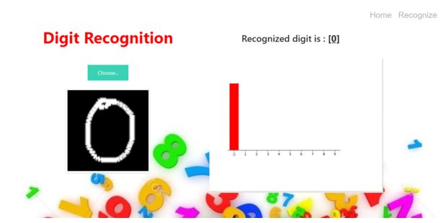

rom keras.models import load_model

from tkinter import *

import tkinter as tk

import win32gui

from PIL import ImageGrab, Image

import numpy as np

model = load_model('mnist.h5')

**def** predict_digit(img):

#resize image to 28x28 pixels

img = img.resize((28,28))

#convert rgb to grayscale

img = img.convert('L')

img = np.array(img)

#reshaping to support our model input and normalizing

img = img.reshape(1,28,28,1)

img = img/255.0

#predicting the class

res = model.predict([img])[0]

**return** np.argmax(res), max(res)

**class** App(tk.Tk):

**def** __init__(self):

tk.Tk.__init__(self)

self.x = self.y = 0

# Creating elements

self.canvas = tk.Canvas(self, width=300, height=300, bg = "white", cursor="cross")

self.label = tk.Label(self, text="Thinking..", font=("Helvetica", 48))

self.classify_btn = tk.Button(self, text = "Recognise", command = self.classify_handwriting)

self.button_clear = tk.Button(self, text = "Clear", command = self.clear_all)

# Grid structure

self.canvas.grid(row=0, column=0, pady=2, sticky=W, )

self.label.grid(row=0, column=1,pady=2, padx=2)

self.classify_btn.grid(row=1, column=1, pady=2, padx=2)

self.button_clear.grid(row=1, column=0, pady=2)

#self.canvas.bind("<Motion>", self.start_pos)

self.canvas.bind("<B1-Motion>", self.draw_lines)

**def** clear_all(self):

self.canvas.delete("all")

**def** classify_handwriting(self):

HWND = self.canvas.winfo_id() # get the handle of the canvas

rect = win32gui.GetWindowRect(HWND) # get the coordinate of the canvas

im = ImageGrab.grab(rect)

digit, acc = predict_digit(im)

self.label.configure(text= str(digit)+', '+ str(int(acc*100))+'%')

**def** draw_lines(self, event):

self.x = event.x

self.y = event.y

r=8

self.canvas.create_oval(self.x-r, self.y-r, self.x + r, self.y + r, fill='black')

app = App()

mainloop()

[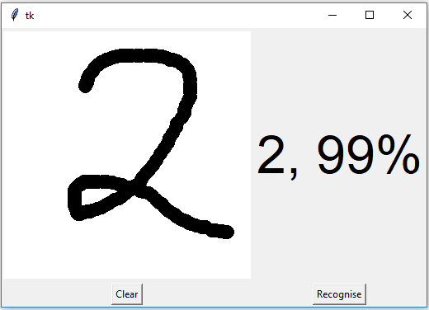](https://data-flair.training/blogs/wp-content/uploads/sites/2/2020/01/python-machine-learning-project-output-as-number-2.png)

CONCLUSION

The selected model for handwritten digit identification effectively balances accuracy, efficiency, and adaptability. By utilizing a Convolutional Neural Network, the system leverages advanced techniques tailored for image recognition, resulting in high performance on diverse datasets. The model's ability to generalize well ensures reliable identification of handwritten digits, making it suitable for real-world applications. Overall, this approach positions the system for ongoing improvements and scalability, addressing future challenges in digit recognition

